Gola Rainforest National Park
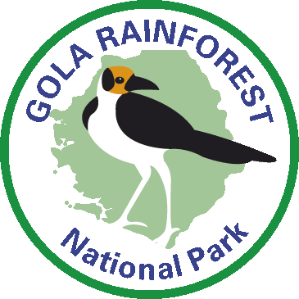
164 Dama Road, Kenema
Phone: 232 (0)76 420418
E mail: info@golarainforest.org
www.golarainforest.org

Research Application

Date

Research Title

- Name of scientists, their affiliated institutions, and nationalities.

Lead Researcher
Name: |  |  |  |  | Surname: |  |  |  |  |  |  |  | Age:
Title:
Nationality: |  |  |  |  |  | Passport Number:
Street:
City: |  |  |  |  | State/Province:
Country: |  |  |  |  |  |  |  |  |  | Zip Code:
Work Phone (with country code): |  |  |  |  |  |  | Home Phone (with country code):
Email: |  |  |  |  |  |  |  | Website:

Accompanying Assistant Researcher(s):
No. | First Name | Surname | Age | Nationality | Passport Number
1
2
3
4
5
6
7

Research Institution
Institution Name:
Department:
Street:
City: |  |  |  |  | State/Province:
Country: |  |  |  |  |  | Zip Code:
Phone Number
Email |  |  |  |  |  | Website

Research Advisor (for students and where applicable)
Name: |  |  |  |  |  | Surname
Title: |  |  |  |  | Department
Institution:
Street:
City: |  |  |  |  | State/Province:
Country: |  |  |  |  |  |  |  |  |  | Zip Code:
Work Phone (with country code): |  |  |  |  |  |  | Home Phone (with country code):
Email: |  |  |  |  |  |  |  | Website:

- Requested dates of research in GRNP.

From |  | To

- Is this research part of academic study or is being done for a professional purpose? Please state here and add details if for a professional purpose.

- Research Objectives
Please provide a brief summary of the key aims and objectives and the key expected research outputs (no more than 500 words)

- Methods and equipment that will be employed in the field.
Please provide a brief description of methods to be used and indication of sample size (e.g. number of study sites, sample stations or specimens to be collected) (no more than 1000 words)

- Comment on the intent to collect or not collect specimens. In case specimens will be collected a complete list has to be provided to GRNP.
Will the project involve the collection of specimens: yes/no (delete as appropriate)
If yes please list the nature and maximum number required

- Estimated need for local workers during the study.
Please indicate type, number, dates and number of days required– for example, local research assistants, local porters, camp cook, etc. (for safety reasons please note visiting researchers are only permitted to enter the forest when accompanied by local staff. Proposals that include a training element for local research assistants will be viewed more favourably than those that do not)

- Indicate what the data will be used for and what types of reports, manuscripts will be produced from the work.
Please indicate what products will be returned to GRNP; for example, species lists with coordinates, a brief report on research methods and results as well as any management recommendations.

- Please indicate the nature and extent of training that will be provided to local staff and national counterparts.
A list of the techniques, sampling or survey approaches etc and whether, and how many, staff will either be ‘shown’ these or trained to be able to complete these unsupervised.

- Please list the nature and extent of your previous field experience in Africa in general and/or West Africa/Sierra Leone in particular.

- Please add any important information not listed above. If you have any questions about conducting research GRNP please indicate them here.

9. Please attach your CV/resume including 2 referees.

To submit this application, please send by email to:

Benjamin Barca
Technical Advisor Research
Gola Rainforest National Park
Kenema, Sierra Leone
benjamin.barca@rspb.org.uk
in Cc: info@golarainforest.org

For office use only
Reviewed by
Research & Monitoring Department
Approved by GRNP

